EEZ BB3 wire harness
- Cooling fan cable
- MCU board power cable
- Dual AC/DC power module AC input
- Single AC/DC power module AC input
- Power module DC input
- Power module Protective Earth
- Ethernet patch cable

Cooling fan cable
Total length | 300 (± 5) mm
Type | 3 wire, already mounted on the cooling fan
Fan: | TME: MF80251V3-1000U-G99  Mouser: N/A
 | 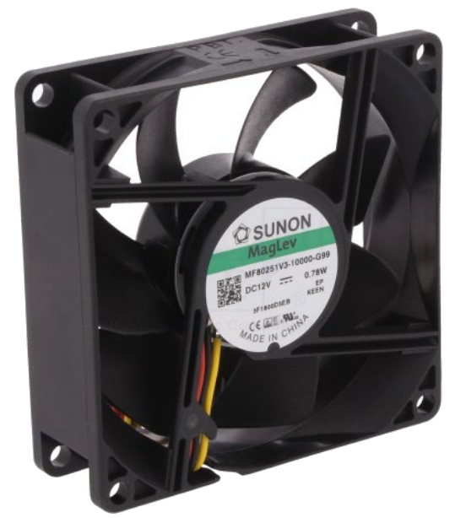
Connectors
Side A | X4, X5 | Side B | N/A
Housing type | Receptacle, 0.1” | Housing type | N/A
TME | MX-22-01-3037 | TME | N/A
Mouser | 538-22-01-3037 | Mouser | N/A
 | 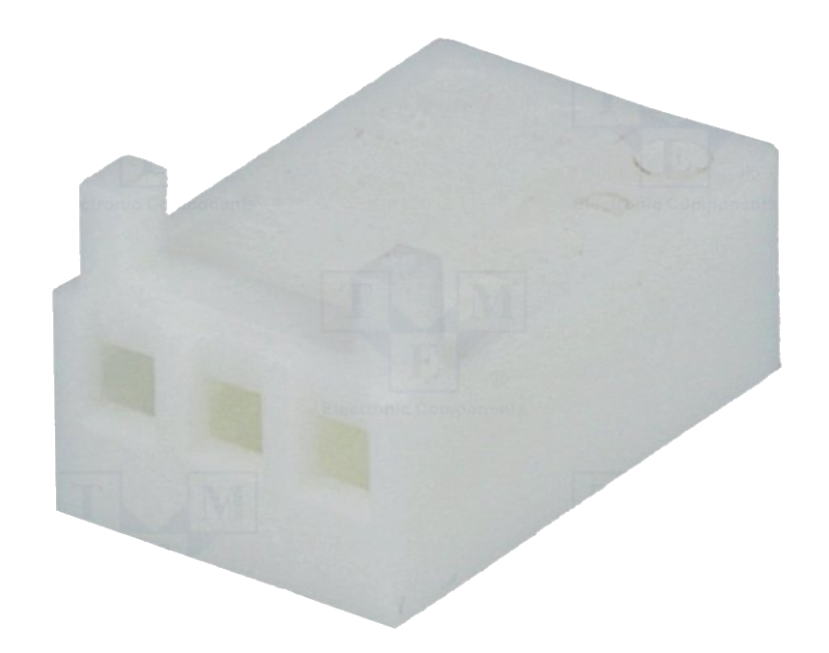
Pin | Female | Pin | N/A
Pin quantity | 3 | Pin quantity | 0
TME | MX-0850-0114 | TME | N/A
Mouser | 538-08-50-0114 | Mouser | N/A
 | 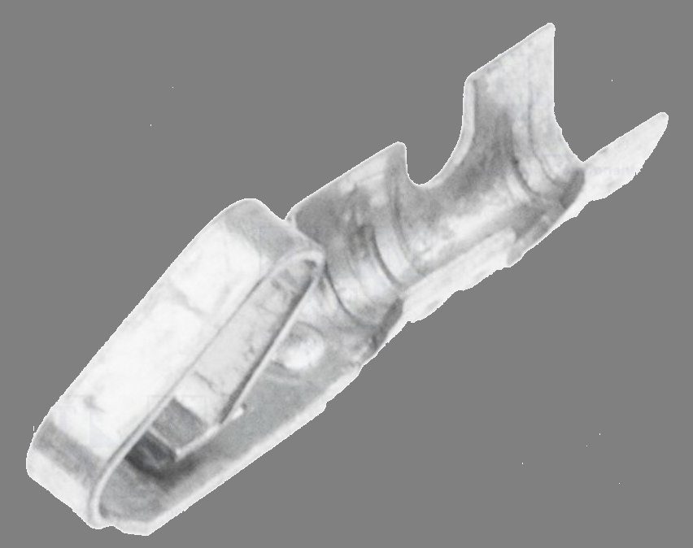
Additional info
Fan is already equipped with cable. Therefore it only has to be terminated with the connector.

Wiring

Name | Position | Color / description
GND | 1 | Black
+12 Vdc | 2 | Red
Sense | 3 | Yellow

Picture

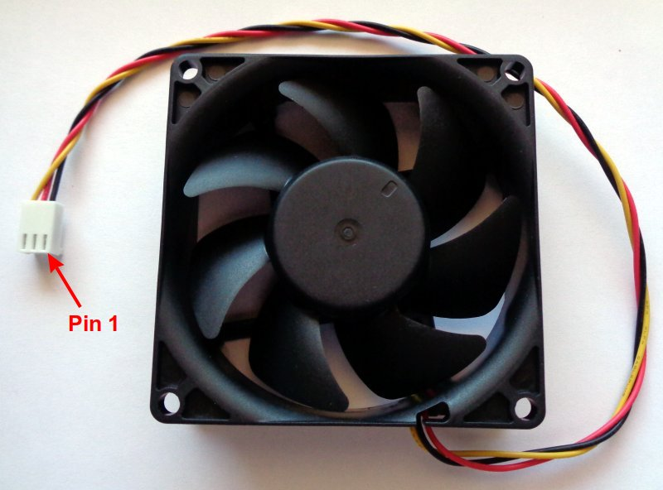
MCU board power cable
Length | 75 or 150 mm assembled or 100 mm custom made
Type | Assembled ribbon cable with IDC connectors; 16x28AWG
TME | FC16150-S
Mouser | N/A
Custom made alternative
IDC female plug; 16 pin for ribbon cable |  | TME | AWP-16
Ribbon cable; 1.27mm; stranded; Cu; 16x28AWG; unshielded; PVC; grey |  | TME | DS1057-16A282R-30.5
IDC connector crimping tool |  | TME | HT-214

Picture

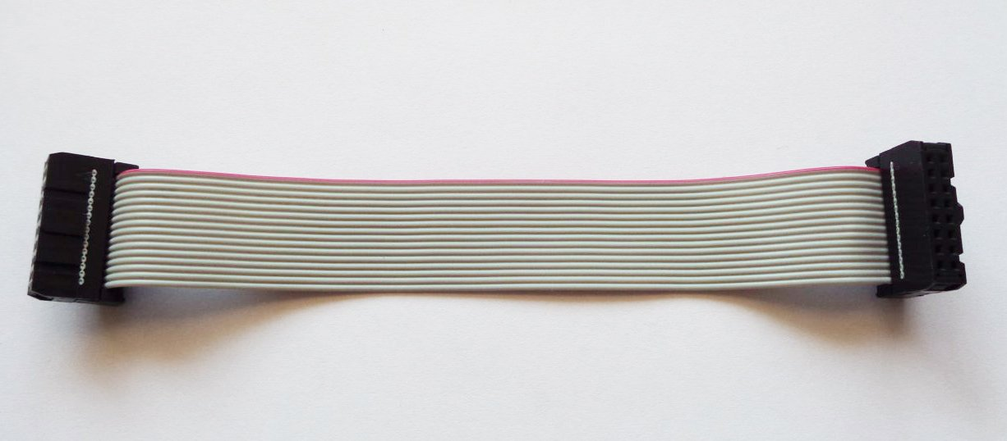
Pinout

Name | Position | Description
PE | 1 | Protective Earth
Reserved | 2
+12 V | 3 | Regulated +12 V output
+12 V | 4 | Regulated +12 V output
+5 V | 5 | Regulated +5 V output
+5 V | 6 | Regulated +5 V output
Gnd | 7
Gnd | 8
Gnd | 9
Reserved | 10 | (+Vaux)
PWR_SSTART | 11 | Triac control (soft-start)
PWR_DIRECT | 12 | Triac control (continuous power)
SSCL | 13 | I2C clock
SSDA | 14 | I2C data
NFAULT | 15 | Fault
+3V3 | 16 | MCU board LDO output

Dual AC/DC power module AC input
Length | 230 (± 5) mm + 250 (± 5) mm
Type | 0.75 mm² (18 AWG) single wire, stranded, min. 250 VAC
TME | Brown: H05VK075BR, Blue: H05VK075BL, Green-Yellow: H05VK075GN/GE
Mouser | Brown: 602-3055-100-07, Blue: 602-3055-100-06, Green-yellow: 602-3055-100-28
Connectors
Side A | AUX PS (X1) | Side B | AC/DC module power output
Housing type | Male, Mini-Fit Jr. | Housing type | Ferrule, single wire
TME | MX-39-01-2065 | TME | H0.75/14D/GY
Mouser | 538-39-01-2065 | Mouser | 845-FID1806GRM
 | 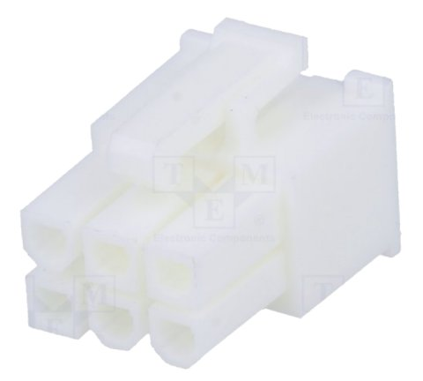 |  | 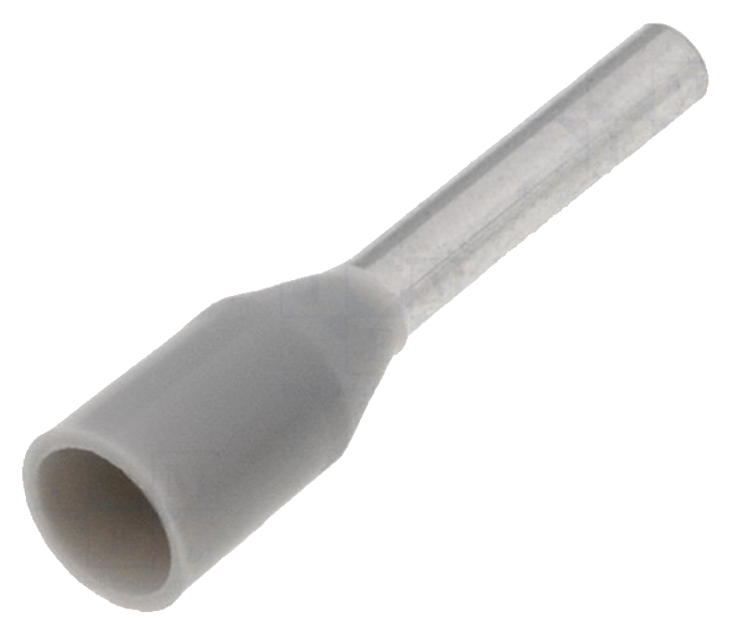
Pin | Female | Quantity | 6
Pin quantity | 6
TME | MX-5556-T3L
Mouser | 538-39-00-0078
 | 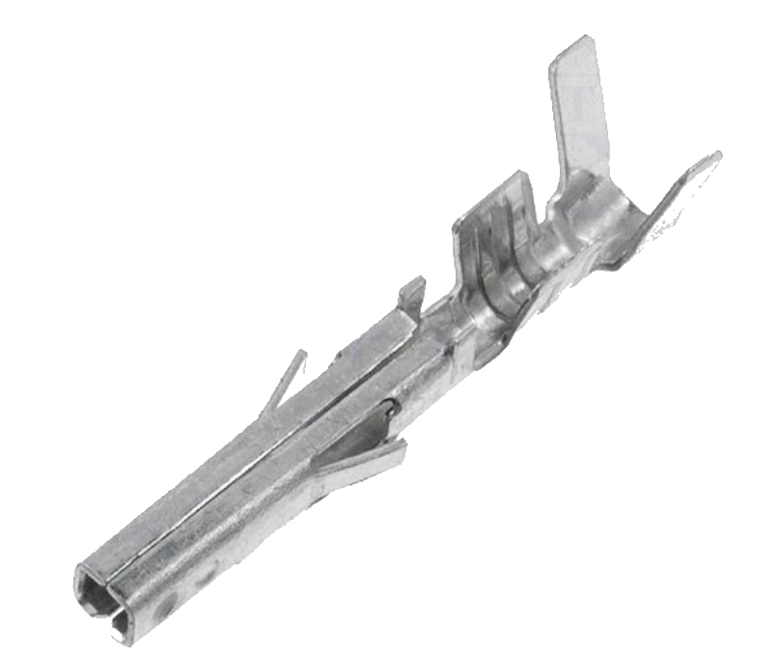

Picture

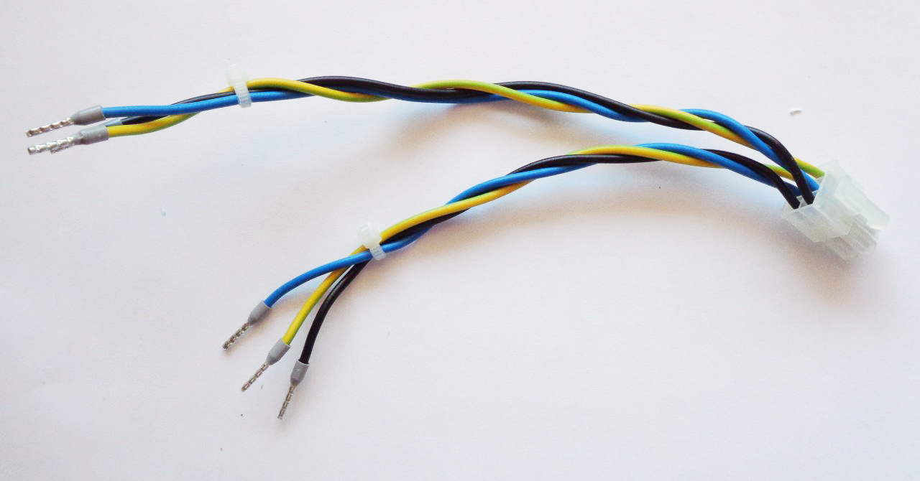
Single AC/DC power module AC input
Length | 250 (± 5) mm
Type | 0.75 mm² (18 AWG) single wire, stranded, min. 250 VAC
TME | Brown: H05VK075BR, Blue: H05VK075BL, Green-Yellow: H05VK075GN/GE
Mouser | Brown: 602-3055-100-07, Blue: 602-3055-100-06, Green-yellow: 602-3055-100-28
Connectors
Side A | AUX PS (X2) | Side B | AC/DC module power output
Housing type | Male, Mini-Fit Jr. | Housing type | Ferrule, single wire
TME | MX-5557-03R2 | TME | H0.75/14D/GY
Mouser | 538-39-01-4030 | Mouser | 845-FID1806GRM
 | 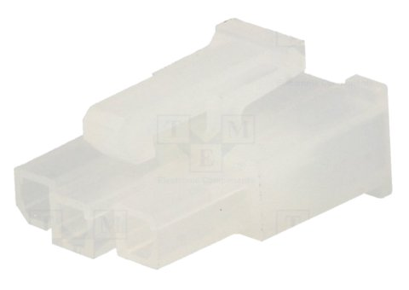
Pin | Female | Quantity | 3
Pin quantity | 3
TME | MX-5556-T3L
Mouser | 538-39-00-0078

Picture

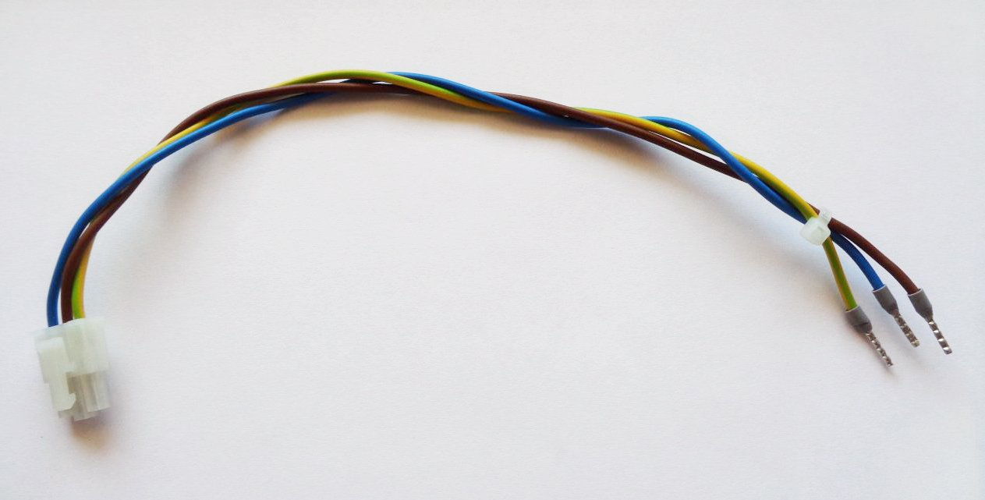
Power module DC input
Length | 350 (± 5) mm
Type | 0.75 mm² (18 AWG) single wire, stranded, min. 250 VAC
TME | Red: H05VK075RT, Black: H05VK075SW
Mouser | Red: 602-3055-100-03 , Black: 602-3055-100-02
Connectors
Side A | Power module (X1) | Side B | AC/DC module power output
Housing type | Male, Mini-Fit Jr. | Housing type | Ferrule, single wire
TME | MX-39-01-3022 | TME | H0.75/14D/GY
Mouser | 538-39-01-3022 | Mouser | 845-FID1806GRM
 | 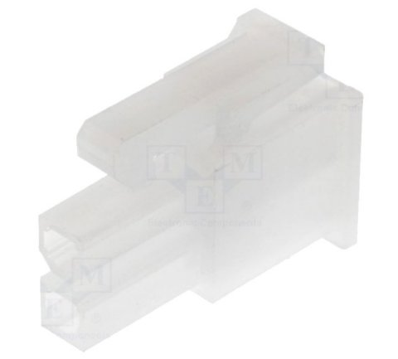
Pin | Female | Quantity | 2
Pin quantity | 2
TME | MX-5556-T3L
Mouser | 538-39-00-0078

Picture

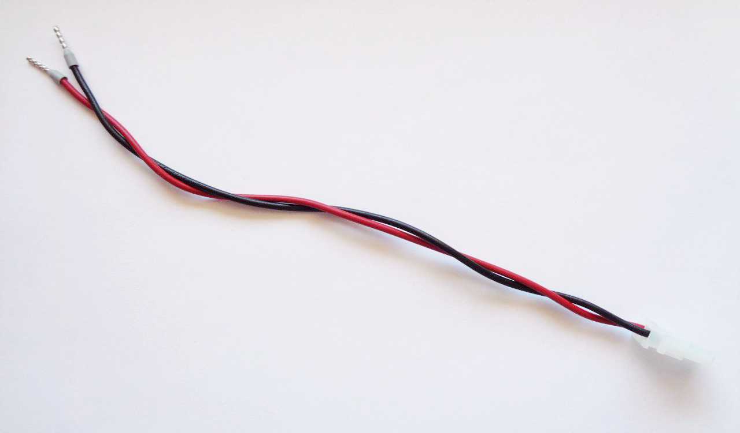
Power module Protective Earth
Length: | Single: 300 (± 5) mm  Dual: 230 + 270 (± 5) mm
Type: | 0.75 mm² (18 AWG) single wire, stranded, min. 250 VAC
TME | Green-Yellow: H05VK075GN/GE
Mouser | Green-yellow: 602-3055-100-28
Connectors
Side A | AUX-PS J2, J3 or J4 | Side B | Power module PE input (J1)
Housing type | Female quick disconnect | Housing type | Female quick disconnect
TME | ST-004/2 or BM01148 | TME | ST-004/2 or BM01148
Mouser | 571-60196-3 | Mouser | 571-60196-3
 | 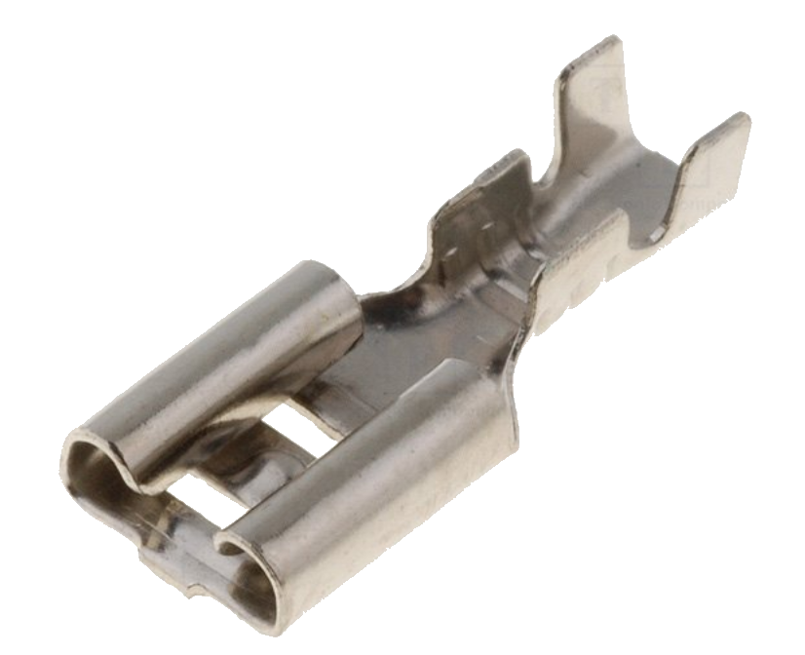
Picture
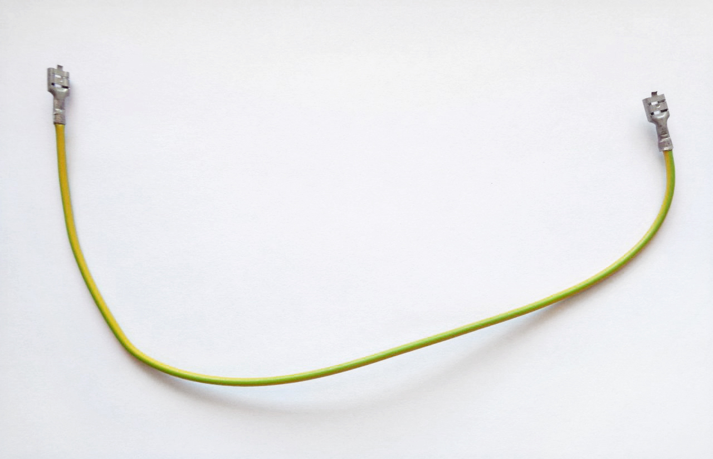
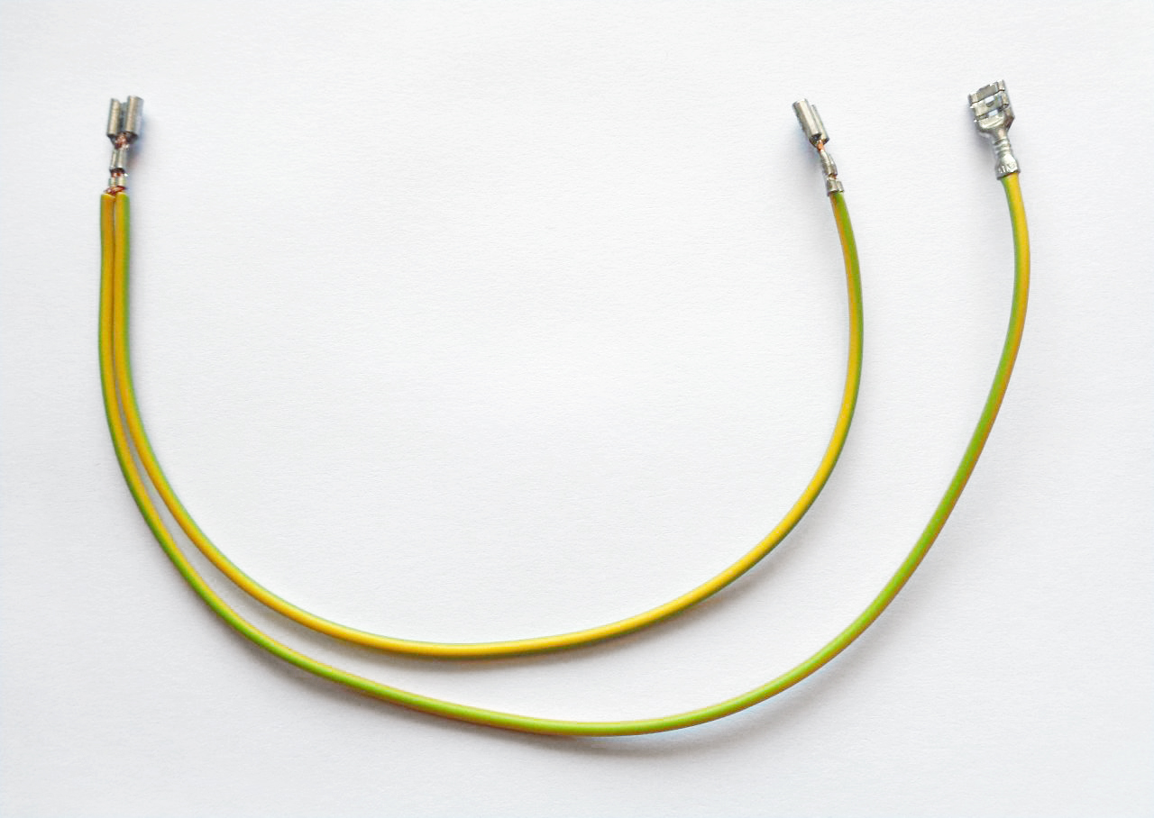

Ethernet patch cable
Length | 300 mm
Type | RJ45 male to 90-degree female panel mount Ethernet extension cable
Alibaba | e.g. https://www.alibaba.com/product-detail/90-degree-right-angle-RJ45-Male_60817134790.html or search for 90 degree right angle RJ45 Male to 90-Degree Female Screw Panel Mount Ethernet LAN Network Extension Cable
TME | N/A
Mouser | N/A

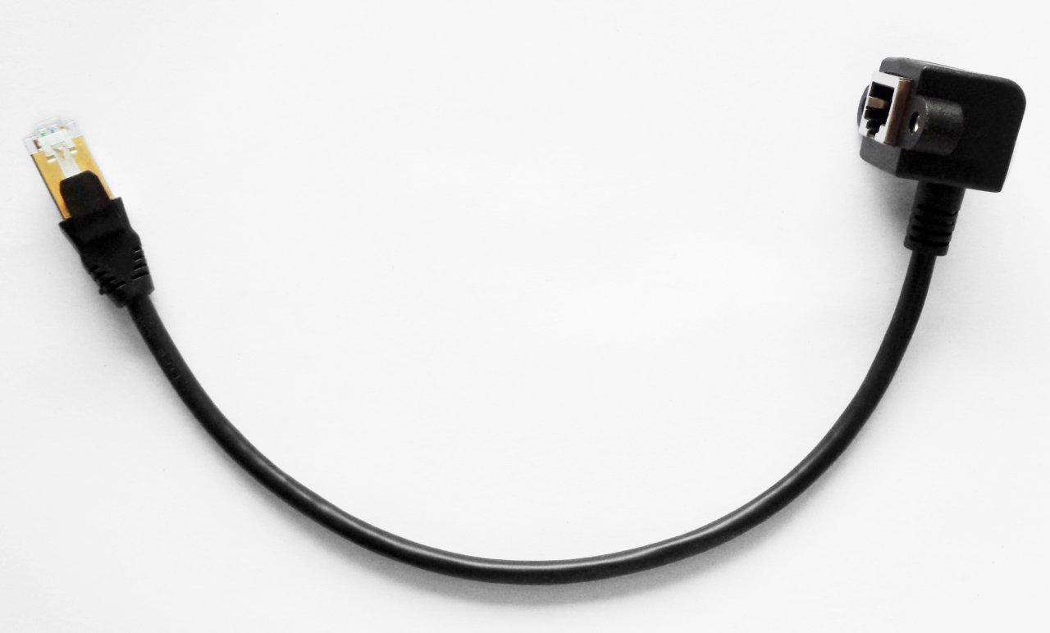

BOM
The following BOM includes items for connecting three power modules.

Type | Part (Mouser) | Part (TME) | Total
3-pin 0.1” receptacle | 538-22-01-3037 | MX-22-01-3037 | 1
6-pin receptacle Mini-Fit Jr. | 538-39-01-2065 | MX-39-01-2065 | 1 | 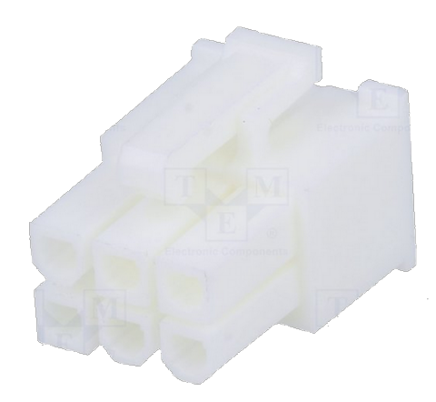
3-pin receptacle Mini-Fit Jr. | 538-39-01-4030 | MX-5557-03R2 | 1 | 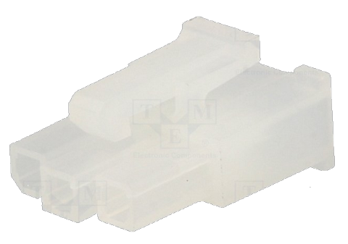
2-pin receptacle Mini-Fit Jr. | 538-39-01-3022 | MX-39-01-3022 | 3 | 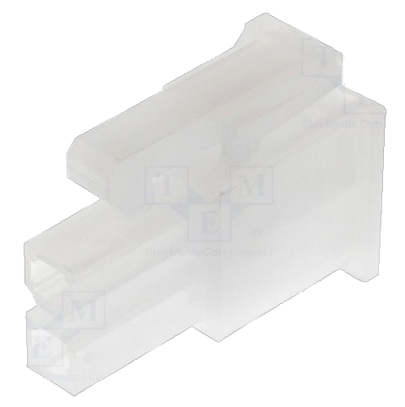
0.1” pin | 538-08-50-0114 | MX-0850-0114 | 3
Mini-Fit Jr. pin | 538-39-00-0078 | MX-5556-T3L | 15
Female quick disconnect | 571-60196-3 | ST-004/2 or BM01148 | 6
0.75 cm² ferrule | 845-FID1806GRM | H0.75/14D/GY | 15
0.75 cm² cable (Brown) | 602-3055-100-07 | H05VK075BR | 0.73 m
0.75 cm² cable (Blue) | 602-3055-100-06 | H05VK075BL | 0.73 m
0.75 cm² cable (Red) | 602-3055-100-03 | H05VK075RT | 1.05 m
0.75 cm² cable (Black) | 602-3055-100-02 | H05VK075SW | 1.05 m
0.75 cm² cable (Yellow-Green) | 602-3055-100-28 | H05VK075GN/GE | 1.49 m
12 Vdc cooling fan | N/A | MF80251V3-1000U-G99 | 1
IDC ribbon cable | N/A | FC16150-S | 0.15 m
Polyamide cable tie; L: 100 mm; W: 2.5 mm | N/A | BMB1025 | 6
Ethernet patch cable | N/A | N/A | 0.3 m

